Report

Opening Story:
You want to surprise your friend, who lives in Delhi, with a thoughtful gift for his birthday.
The gift is a small, delicate glass item that holds personal significance.
You pack the item carefully and take it to a traditional courier service, XYZ, for delivery.
You find the courier fee surprisingly high for such a small package.
With your friend's birthday only a couple of days away, you hope the parcel will arrive on time, despite an uncertain delivery time.
Two days later, you call your friend to let him know to expect the package.
Your friend is concerned about the timing so he can be available to receive it.
When the package finally arrives, your friend opens it and finds the glass item shattered and unrecognizable.
The situation leaves you feeling frustrated, as your effort, expense, and emotion invested in the gift were ultimately wasted.

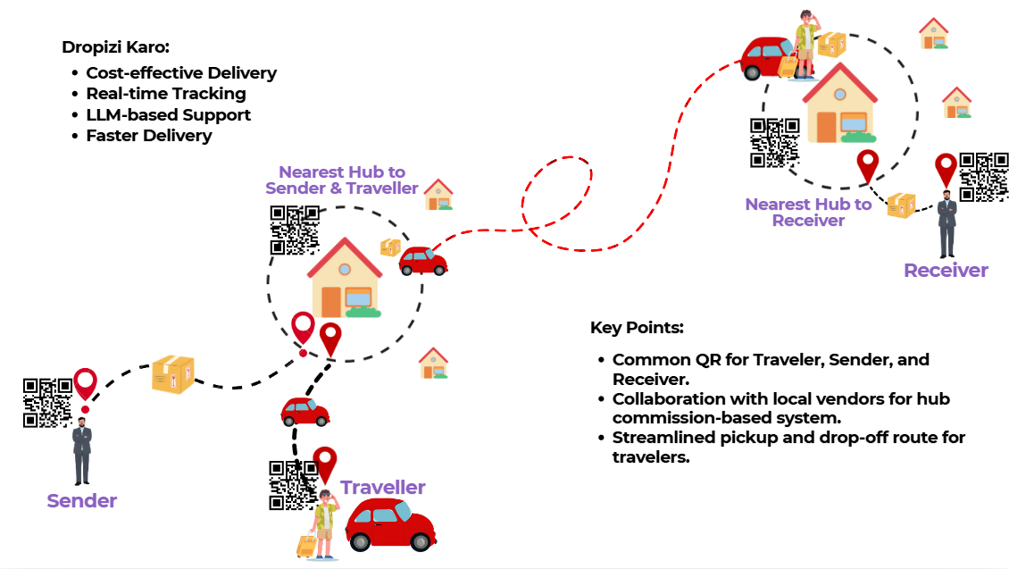

Introduction
The ₹71,000 crore parcel delivery market is vital to India’s logistics sector, serving individuals and businesses. Traditional couriers remain popular, but innovations like peer-to-peer delivery and crowd-shipping are reshaping the industry. This report examines key competitors—their business models, services, strengths, and weaknesses—to offer insights that will help Dropizi understand its market position and refine its strategy.
Product Working Flow Model
1. Customer and traveller both log into the system.
2. The platform matches customer with traveller based on delivery and travel routes.
3. Customer retrieves details of potential travellers.
4. Customer selects a traveller for their parcel.
5. Traveller retrieves details of available parcels.
6. Traveller selects a parcel to deliver.
7. System checks if both customer and traveller are ready to connect.
8. If yes, traveller is assigned to the parcel; if no, the process is cancelled.
9. A delivery schedule is set based on the agreed date and time.
10. A QR code is generated for both customer and traveller.
11. Customer drops the parcel at the nearest booth using the QR code.
12. Customer makes the payment for the service.
13. Traveller picks up the parcel from the nearest booth.
14. Traveller transports the parcel to the destination booth.
15. If the parcel is delivered, the process is completed.
16. If not, the system assigns the parcel to the next available traveller.

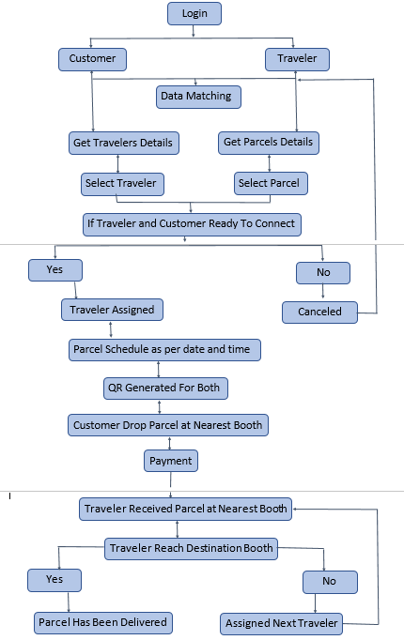

The Problem:
Individuals sending single parcels often face issues with traditional courier services, which are designed for bulk shipments. Although single senders make up 25% of the ₹71,000 crore courier market, they struggle with high costs, uncertain delivery times, and poor handling of valuable items. There’s a need for a more affordable, reliable, and personal solution for sending cherished parcels.

Introducing Dropizi:
"That’s where Dropizi comes in. Dropizi is the answer to the challenges faced by people wanting to send personal, single packages. Imagine having access to a network of trusted travelers ready to deliver your gift to Delhi while they're already making the journey. With Dropizi, your package not only arrives on time but also remains safe and secure in the hands of a fellow traveler who cares."
How Dropizi Works:
"Sending a parcel with Dropizi is straightforward and stress-free:
1. User-Friendly App: You log into Dropizi, fill in your package details, and instantly see a list of travelers already heading to Delhi.
2. Affordable Pricing: Choose a traveler and drop-off point. Dropizi calculates a clear, affordable price based on size, weight, and distance.
3. Secure Payment: You pay securely using a QR code on the app, ensuring your payment is safe and traceable.

The Hub-Based System:
What truly sets Dropizi apart is the integration of our Hub system, which serves as a secure drop-off point where Customers and Travelers coordinate efficiently without needing to meet directly. Here’s how it works:
Secure Drop-Off: The Customer drops the parcel at the Hub and scans a QR code to lock in package details and assign it to a Traveller.
Pickup Verification: The Traveller verifies the parcel by scanning the same QR code upon collection.
Delivery Confirmation: At the final destination, the Traveller scans the QR code again to confirm secure delivery for both sender and recipient.
The Solution:
"This system not only cuts down on delivery times but also significantly lowers costs for Travelers, providing an incentive to use Dropizi over traditional platforms. Each step is tracked and secured, minimizing risks and ensuring that packages are treated with care."

Market Opportunity:
"Throughout India, millions of people are sending single parcels daily, many without effective delivery options. Individual senders are left underserved, while Dropizi is primed to meet their unique needs."

The Technology Behind Dropizi:
"Using advanced geolocation technology, Dropizi matches senders with Travelers in real-time. Our app features real-time tracking, secure QR-based payments, and user verification, creating a customer experience as seamless as booking a ride-sharing service—but for parcels."

Market Competitor Overview:
Traditional courier services like DHL, Blue Dart, DTDC, and India Post dominate the market but often have high costs, unreliable delivery times, and impersonal handling, making them less suitable for personal parcel deliveries.
Amazon Logistics, Rapido, and Lalamove focus on last-mile delivery but are geared toward e-commerce or bulk deliveries, leaving a gap for small, personal deliveries.
Newer players like Pickrr and Wefast emphasize affordable, tech-driven solutions, highlighting a demand for innovation in the market.
Dropizi addresses this gap with a community-driven delivery model, providing reliable, cost-effective, and personal parcel delivery as a true alternative to traditional services.

Vision for Growth:
"Our vision is to make Dropizi the go-to platform for anyone looking to send parcels personally and affordably. With your investment, we’ll enhance Dropizi’s technology, expand our user base, and cement our place in the mainstream logistics ecosystem."

Final Call to Action:
“We're not just building a delivery service; we’re forging connections between people, one package at a time. Dropizi is where personal delivery meets affordability and reliability, ensuring that your thoughtful gifts arrive on time, intact, and with care. Join us in creating a delivery experience that millions of people across India have been waiting for."

Closing with Impact:
"Dropizi isn’t just about logistics; it’s about creating a connection. We believe in delivering parcels that matter with the care they deserve. Let’s make this vision a reality."

Target Market:
Dropizi Market Entry Report:
Dropizi aims to provide a personalized parcel delivery solution tailored for individual senders. Unlike Traditional courier services, Dropizi leverages a unique model by connecting people who are traveling with those who need items delivered, offering a cost-effective and flexible alternative for personal parcel shipments.
Market Overview of Indian Courier, Express, and Parcel (CEP) Industry:
Market Size: The Indian courier and logistics sector is valued at approximately ₹71,730 crore (USD 8.58 billion) as of 2024, with a projected growth to ₹1,33,405 crore (USD 15.93 billion) by 2030.
Growth Rate: The sector is growing at a compound annual growth rate (CAGR) of around 10.87%, driven largely by e-commerce but also by rising personal and SME delivery needs.
E-commerce Influence: E-commerce contributes roughly 75-80% of parcel volumes due to online Shopping demand. However, the remaining 20-25% market segment, valued at about ₹18,750 crore, is driven by personal shipments and individual-to-individual deliveries, where Dropizi will operate.
Individual Delivery Market Segment Analysis:
Current Share: Personal parcel shipments represent an estimated 20-25% of the total market, translating to value of around ₹18,750 crore.
Demand Drivers:
Urbanization: Rising migration and urban populations boost demand for flexible, reliable, and affordable Parcel services for individuals.
Personalization Trend: Increasingly, customers prefer services that offer tailored, on-demand delivery, making a personalized delivery approach an attractive alternative.
Traveler Economy: The rise of a mobile workforce and frequent travelers creates a pool of potential Delivery agents for the Dropizi model.
Key Competitors:
Blue Dart Express: Largest player in the Indian courier industry with a market cap of ₹17,470 crore. Primarily targets e-commerce and corporate clients.
Gati, DTDC, Allcargo Logistics: Compete in both B2B and B2C spaces with services for document and parcel deliveries.
Emerging Startups: Several tech-enabled courier startups focus on last-mile delivery and urban logistics but typically serve B2B or e-commerce demands rather than personal deliveries.
Dropizi’s Unique Value Proposition:
Dropizi’s entry into the market leverages:
Personalized Service: Customizable delivery options based on individual needs.
Traveler-Based Model: Offers a unique pool of delivery options, allowing for flexible pricing and routing.
Real-Time Geolocation Matching: Matching senders and travelers based on location, enabling efficient, nearby options for parcel drop-off and pick-up.
Future Scope and Market Opportunities:
Growth of Non-E-commerce Deliveries: With the market heavily influenced by e-commerce, personalized non-e-commerce deliveries offer a less saturated space. As personal deliveries become more common due to urbanization, Dropizi can capture a rising demand among individuals.
Technology Integration: Leveraging advanced geolocation, predictive routing, and secure traveler-sender matching, Dropizi can stand out as a tech-driven solution.
Partnerships with Local Businesses: Collaborating with local stores, pharmacies, and other small businesses for quick, hyperlocal deliveries could expand Dropizi’s market reach.
Expanding the Traveler Network: Building a robust network of travelers willing to make deliveries on a regular basis can create competitive pricing advantages, attracting more users.
Financial Projections for Dropizi:
Given the potential 25% share of the CEP market focused on non-e-commerce deliveries, Dropizi’s target market is valued at approximately ₹18,750 crore. Achieving even a modest market penetration rate of 1% within this segment could yield annual revenue potential of approximately ₹187.5 crore.
Long-Term Financial Goals:
3-Year Goal: Capture 2-5% of the personal parcel market, aiming for ₹375-₹937.5 crore.
5-Year Goal: Expand market penetration to 7-10%, focusing on urban markets and expanding partnerships.
Dropizi is poised to capture a promising niche in the Indian courier industry. By focusing on personalized, traveler-based parcel delivery for individuals, Dropizi can tap into an underserved segment valued at ₹18,750 crore. With strategic positioning, a focus on technology, and a commitment to customer satisfaction, Dropizi can become a preferred option for non-e-commerce parcel shipments in India.

Competitive Analysis: Dropizi vs. Key Players in Parcel Delivery Market
- DHL:
Strengths: DHL’s global presence, efficient tracking, and brand reliability are unmatched, particularly for express services and international shipping.
Weaknesses: High costs and a lack of focus on personal or small shipments limit its appeal for individual customers with delicate or single-item parcels.
Dropizi Advantage: More affordable for small-scale, personal deliveries and offers a personalized handling approach for fragile items that DHL typically cannot provide.
- Blue Dart:
Strengths: Blue Dart’s extensive network across India and established infrastructure make it a go-to for reliable express services within the country.
Weaknesses: High pricing and limited-service flexibility can be restrictive for individual customers with occasional shipping needs.
Dropizi Advantage: Provides flexibility through its traveller-based model, enabling customers to find delivery options that fit both their budget and timing, enhancing accessibility for individuals with occasional delivery needs.
- DTDC:
Strengths: DTDC offers competitive pricing with a broad network in India, particularly focused on supporting e-commerce.
Weaknesses: Limited innovation, slower international delivery, and handling issues make DTDC less appealing for high-value, fragile items.
Dropizi Advantage: Better suited for individuals looking for careful handling and a reliable network for personal items, filling a niche that DTDC’s model doesn’t fully support.
- India Post (EMS):
Strengths: India Post’s affordability and unmatched rural reach make it ideal for economical deliveries, even to remote areas.
Weaknesses: Slower delivery times, limited customer support, and reliability issues for fragile or high-value parcels.
Dropizi Advantage: Provides a faster, community-driven solution that leverages local travellers, ensuring timely delivery and safer handling of delicate items.
- Amazon Logistics:
Strengths: Amazon’s logistical infrastructure and efficiency in e-commerce deliveries are difficult to match, particularly for Amazon products.
Weaknesses: Limited to Amazon shipments and bulk logistics; non-e-commerce users find it less accessible.
Dropizi Advantage: Serves as an independent, user-friendly option with a wider appeal for those looking to ship outside of Amazon’s ecosystem, particularly small, personal parcels.
- Rapido:
Strengths: Fast and affordable for short-distance, intra-city deliveries; app-based and flexible.
Weaknesses: Limited to lightweight packages within city limits, lacking support for long-distance or delicate deliveries.
Dropizi Advantage: Supports both city-wide and longer routes for a variety of package types, including fragile items, offering more flexibility and reach than Rapido’s model.
- Lalamove:
Strengths: On-demand, affordable, and app-integrated delivery is convenient for urban deliveries.
Weaknesses: Limited brand presence in India, primarily focused on metropolitan areas with relatively high pricing for larger parcels.
Dropizi Advantage: By using travellers from various locations, Dropizi can expand beyond city limits at a lower cost, providing personal handling for smaller deliveries across wider geographies.
- Pickrr:
Strengths: Tech-driven, low-cost solutions for e-commerce businesses and efficient tracking features.
Weaknesses: Not focused on individual senders, and delivery consistency can be variable.
Dropizi Advantage: Caters specifically to individual customers, providing a more reliable and affordable delivery alternative for one-time or infrequent personal shipments.
- Wefast:
Strengths: Cost-effective for small shipments and allows flexible deliveries based on users’ schedules.
Weaknesses: Limited scalability, with reliability concerns for parcels handled by unknown travellers.
Dropizi Advantage: Emphasizes security and reliability through QR-code-based verification, real-time tracking, and a carefully vetted network of travellers, ensuring better security and trustworthiness in each delivery.

Dropizi’s Unique Selling Points:
Personalized and Safe Delivery: Unlike large couriers, Dropizi prioritizes careful handling of fragile items, catering specifically to individuals needing secure delivery.
Affordability: The community-driven model minimizes costs, providing a budget-friendly option for personal parcel deliveries.
Flexibility and Accessibility: By leveraging an existing network of travellers, Dropizi offers flexible delivery times and wider reach.
Tech Integration: Real-time tracking and secure QR-code verification enhance trust and transparency throughout the delivery process.
Challenges:
Market Reach: Scaling beyond metropolitan regions and gaining rural access could be challenging initially.
Brand Awareness: Competing against established brands will require targeted marketing to build customer trust.
Traveller Vetting: Ensuring the safety and reliability of its traveller network is critical for customer confidence in the service.

Development Roadmap:
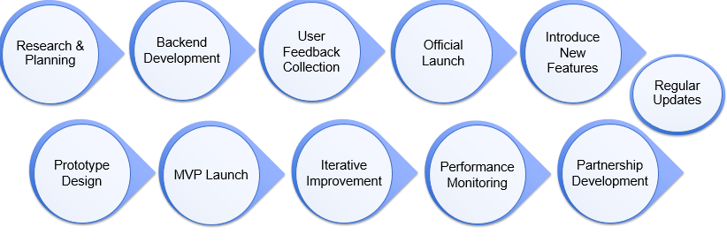

Weight (kg) | Initial 50 km (₹1.5/km) | Additional Distance (₹1/km) | Weight Multiplier | Total Distance Cost  (80 km) | Final Price
1 kg | ₹75 | ₹30 | 1.0 | ₹105 | ₹105
3 kg | ₹75 | ₹30 | 1.3 | ₹105 | ₹136.50
5 kg | ₹75 | ₹30 | 1.5 | ₹105 | ₹157.50
10 kg | ₹75 | ₹30 | 2.0 | ₹105 | ₹210

Business Model:
1. Pricing Model for Parcel Delivery

2. Example Calculation for 3 kg Parcel over 80 km
Base Distance Cost for the first 50 km:
1.5per km×50km=₹75
Additional Distance Cost for the remaining 30 km:
1per km×30km=₹30
Total Distance Cost:
₹75+₹30=₹105
Weight Multiplier for 3 kg:
Total Cost=₹105×1.3=₹136.50

3. Revenue Distribution Model:
Revenue Stream | Percentage | Amount (₹)
Dropizi Platform | 15% | ₹20.48
Hub Owner | 10% | ₹13.65
Traveler | Remaining 75% | ₹102.38

4. Key Takeaways
Dropizi Platform Commission: A small percentage (15%) from each delivery transaction ensures platform sustainability.
Hub Owner's Share: 10% of the total price goes to the hub owner for facilitating delivery hubs.
Traveler’s Revenue: The traveler, who delivers the parcel, receives 75% of the total cost, making it a profitable and attractive model for frequent travelers.

Conclusion
Dropizi has the potential to disrupt the traditional courier market by offering a more affordable, personalized, and flexible alternative to established competitors. While the existing players have significant advantages in terms of infrastructure and brand recognition, Dropizi’s innovative peer-to-peer model and focus on community-driven solutions provide it with a unique edge in the growing parcel delivery market. With the right strategy, technology, and marketing, Dropizi could carve out a niche in the underserved personal parcel delivery market.

Resources for Dropizi’s Business Model:
- Business Model Basics:
  - Source: Osterwalder, A. & Pigneur, Y. (2010). Business Model Generation: A Handbook for Visionaries, Game Changers, and Challengers. Wiley.
  - Link: Business Model Generation
- Pricing Strategies:
  - Source: Monroe, K. B. (2003). Pricing: Making Profitable Decisions. 3rd Edition. McGraw-Hill.
  - Link: Pricing: Making Profitable Decisions
- Revenue Models:
  - Source: Magretta, J. (2002). Why Business Models Matter. Harvard Business Review.
  - Link: Why Business Models Matter

Competitors in the Parcel Delivery Market
- DHL
  - Source: DHL Official Site.
  - Link: DHL
- Blue Dart
  - Source: Blue Dart Official Site.
  - Link: Blue Dart
- DTDC
  - Source: DTDC Official Site.
  - Link: DTDC
- India Post (EMS)
  - Source: India Post Official Site.
  - Link: India Post
- Amazon Logistics
  - Source: Amazon Logistics Overview.
  - Link: Amazon Logistics
- Rapido
  - Source: Rapido Official Site.
  - Link: Rapido
- Lalamove
  - Source: Lalamove Official Site.
  - Link: Lalamove
- Pickrr
  - Source: Pickrr Official Site.
  - Link: Pickrr
- Wefast
  - Source: Wefast Official Site.
  - Link: Wefast

Additional Reading on Parcel Delivery Trends
- Global Trends in Logistics and Supply Chain Management:
  - Source: McKinsey & Company.
  - Link: McKinsey on Logistics
- Crowdsourced Delivery Models:
  - Source: Journal of Business Models, Vol. 5, No. 2.
  - Link: Crowdsourced Delivery

